OpenCores 10/100 Ethernet MAC with Avalon Interface

Version 9.1

February 2010

Table Of Contents
Table Of Contents 2
Introduction 3
License 3
Instantiating the Avalon OpenCores 10/100 MAC. 4
Installing the source files. 4
Instantiating the MAC in SOPC Builder 4
Configuring the MACs options 5
Connecting the MAC to the Avalon BUS 6
Classic vs. Current Component 6
Compiling the project in Quartus 7
Design Changes 8
Design Files 8
Removed Files 8
Modified Files 8
Added Files 8
Behavioral changes 8
Software Driver for InterNiche TCP/IP Stack 10
Software Files 10
Software Driver Options 10
Interfacing with your PHY chip 12
Test Platforms 13
Revision History 13

Introduction
This document describes a modified version of the OpenCores 10/100 Ethernet MAC available at http://www.opencores.org/projects.cgi/web/ethmac/overview . This modified version replaces the original wishbone interface module with an Avalon interface module. The Avalon version corrects some of the problems found in the original wishbone interface and also offers compile-time programmable transmit and receive FIFOs.
Specifically, the Avalon version addresses the problems seen in the Wishbone version when interfacing to DDR memory or any memory interface which may provide significant backpressure on the DMA controllers.
The module is bundled as a custom component which can be instantiated in Altera’s SOPC Builder.
In addition, a software driver is included to be able to use the MAC in conjuction with Altera’s implementation of the InterNiche TCP/IP stack. The driver has been tested with both the UCOSII and superloop versions of the stack. You can implement Altera’s “Simple Socket Server” reference software project to test the MAC in your design.
Hopefully this work can be of use to somebody.

License
In accordance with the existing version of the OpenCores 10/100 Ethernet MAC. This derived work is licensed under the GNU Lesser General Public License. The license can be obtained at http://www.gnu.org/licenses/lgpl.html . As such, the following applies to all source files added to the OpenCores 10/100 Ethernet MAC. The exception to this is those files which are not a derived work of the OpenCores MAC. Specifically, this implementation depends on FIFO implementations from Altera Corporation. Those FIFOs and their corresponding source code are subject to licensing from Altera.

Copyright (C) 2007

This source file may be used and distributed without restriction provided that this copyright statement is not removed from the file and that any derivative work contains
the original copyright notice and the associated disclaimer This source file is free software; you can redistribute it and/or modify it under the terms of the GNU Lesser GeneralPublic License as published by the Free Software Foundation; either version 2.1 of the License, or (at your option) any later version.

This source is distributed in the hope that it will be useful, but WITHOUT ANY WARRANTY; without even the implied warranty of MERCHANTABILITY or FITNESS FOR A PARTICULAR PURPOSE. See the GNU Lesser General Public License for more details.

You should have received a copy of the GNU Lesser General Public License along with this source; if not, download it from http://www.gnu.org/licenses/lgpl.html .

Instantiating the Avalon OpenCores 10/100 MAC.
This section designs the steps necessary to instantiate and use the Avalon OpenCores 10/100 Ethernet MAC in your design.

Installing the source files.
In order for SOPC Builder to make use of the MAC, the source folder must be located appropriately. Place the “eth_ocm” source folder under the “ip/usercomponents” directory of your Altera install. As an example, on a typical Windows installation, the “eth_ocm” folder would be located at “C:\altera\91\ip\user_components\eth_ocm”. You may optionally place the “eth_ocm” source folder in the same directory as your SOPC system.

Instantiating the MAC in SOPC Builder
The Avalon OpenCores 10/100 Ethernet MAC component is located in the “Interface Protocols/Ethernet” component group as shown in Figure 1.

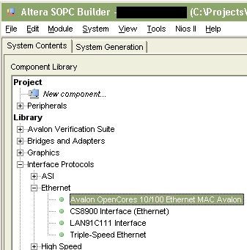
Figure 1 OpenCores MAC component location in SOPC Builder

Double-click on the component to add it to your system.

Configuring the MACs options
Adding the MAC to your system will bring of the Add component dialog box for your instance of the component as shown in Figure 2.

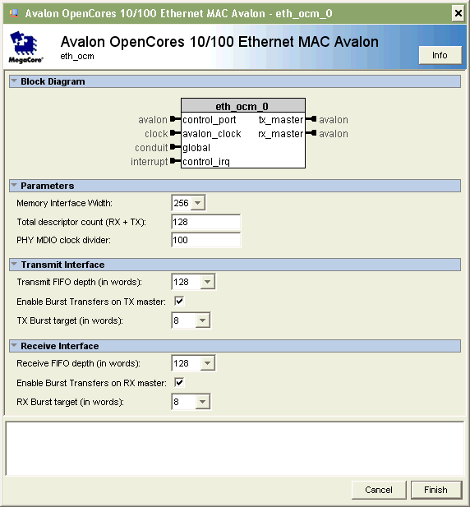
Figure 2 Configuring MAC options.

The configuration parameters are explained below: The explanations are also available by clicking the “Info” button for the component.

Memory Interface Width | Selects the width of the MAC's Transmit and Receive memory master ports. Ideally you should match this to the width of your memory interface for maximum efficiency. Increased values result in increased resource utilization and may negatively impact fmax.
Total descriptor count (RX + TX) | Selects the total number of DMA descriptors for the MAC (both Transmit and Receive). The value must be between 2 and 128
PHY MDIO clock divider | Selects the amount by which to divide the system clock to obtain the clock for the MDIO interface to the PHY. 2.5MHz is typically the desired clock rate for the PHY interface. As an example, if the system clock is 100MHz, a divider value of 40 would give a clock rate of 2.5MHz
Transmit FIFO depth (in words) | Configures the depth of the transmit FIFO. The width of the FIFO is specified by the "Memory Interface Width" parameter. The purpose of the transmit FIFO is to prevent an underrun while transmitting data. A large value here does not make much sense because packets are transmitted synchronously. A value of 128 is sufficcient for most applications
Enable Burst Transfers on TX master | Enables or disables bursting on the Transmit memory master port
TX Burst target (in words) | Configures the burst target (desired burst count) for the Transmit memory master port. The memory master will read this number of words each burst unless fewer words are needed. The burst target can be no more than half the size of the Transmit FIFO depth.
Receive FIFO depth (in words) | Configures the depth of the receive FIFO. The width of the FIFO is specified by the "Memory Interface Width" parameter. The receive FIFO serves two purposes: 1 - It prevents an overrun as data is received from the PHY. 2 - It can act as a packet buffer for incoming packets in the event that the processor interface is too busy to handle the incoming packets. The larger the FIFO, the more packet data can be buffered but increases FIFO RAM usage.
Enable Burst Transfers on RX master | Enables or disables bursting on the Receive memory master port
RX Burst target (in words) | Configures the burst target (desired burst count) for the Receive memory master port. The memory master will write this number of words each burst unless fewer words are needed. The burst target can be no more than half the size of the Receive FIFO depth.

Connecting the MAC to the Avalon BUS
The Avalon OpenCores MAC contains one Avalon slave port (for host processor control) and two Avalon master ports (one for transmit DMA and one for receive DMA). Figure 3 shows an example implementation of the MAC connected to a NIOSII processor and DDR2 memory.

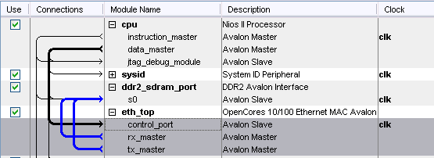
Figure 3 Connecting the MAC to the Avalon BUS.

Compiling the project in Quartus
Before you compile your project in Quartus, you must add the must add the path to the OpenCores MAC component to your project’s list of user libraries for the project to compile properly. Failure to do so will result in compile time error messages stating that certain design entities cannot be found.
Figure 4 shows the eth_ocm component added as a user library for a project.

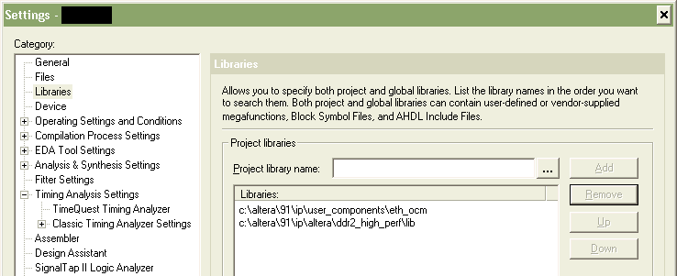
Figure 4 Adding OpenCores MAC component as a user library in Quartus.

Design Changes
This section describes the changes made to the OpenCores MAC in order to implement the Avalon interface.

Design Files

Removed Files
The following files were removed from the original implementation:
- eth_fifo.v
- eth_spram_256x32.v
- eth_wishbone.v
- xilinx_dist_ram_16x32.v

Modified Files
- eth_top.v – Renamed to eth_ocm.v (our implementation had an instance called eth_top). Modified top level port list for new Avalon interface. Removed byte select logic on control port. Changed module to instantiate eth_avalon in place of eth_wishbone.
- eth_registers.v – Modified to remove byte select logic which is unused in the implementation.

Added Files
- eth_avalon.v – Replaces eth_wishbone.v. Encapsulates descriptor interface and TX and RX DMA controllers
- eth_avalon_bd_ram.v – Implements descriptor ram. This module implements an Altera altsyncram component.
- eth_avalon_dma_fifo.v – Implements dual-clock FIFOs used in both the TX and RX DMA controllers. This module implements an Altera dcfifo component.
- eth_avalon_functions.v – Implments various constant functions used at compile time.
- eth_avalon_rxdma.v – Implements the receive DMA interface.
- eth_avalon_txdma.v – Implements the transmit DMA interface.
- eth_dc_reg.v – Implements a handshaking scheme for passing a signal across two clock domains.

Behavioral changes
In the original wishbone implementation, an interrupt would be generated on the Busy_IRQ line if a frame was received but there was no receive descriptor ready to receive it. The Avalon implementation is slightly different. In the Avalon implementation, a receive FIFO exists between the MAC core and the DMA interface. Thus there exists the potential for many entire frames to be buffered in the FIFO waiting for a receive descriptor to be available.
In the Avalon implementation, the Busy IRQ is asserted if a new frame is received and the receive FIFO is full. If the FIFO becomes full while receiving a frame that frame is truncated and the OR (overrun) bit is set in the descriptor when the DMA transfer is complete.

Software Driver for InterNiche TCP/IP Stack
This section describes the provided software driver for the OpenCores MAC that is designed to operate in conjuction with Altera’s implementation of the InterNiche TCP/IP stack. This driver has been tested with both the UCOSII and superloop versions of the InterNiche Stack.

Software Files
The software driver is made up of the following files:
- inc/eth_ocm_regs.h – Contains the register mappings for the OpenCores MAC with corresponding IOWR and IORD macros for accessing those registers.
- HAL/inc/eth_ocm.h – Not much. Contains some default macros for the OpenCores MAC. Also defines the INSTANCE and INIT macros to nothing in the event that the Altera InterNiche Stack is not being used. These macros are called when the MAC is initialized in alt_sys_init.
- HAL/inc/eth_ocm_desc.h – Provides macros for accesing the MAC’s descriptors and also provides the TX and RX descriptor bit mappings.
- HAL/inc/eth_ocm_phy.h – Provides macros and function prototypes for accessing the external PHY chip via the MAC’s MDIO interface.
- HAL/inc/ins_eth_ocm.h – Main header file for OpenCores MAC InterNiche software driver. Contains several structs used during runtime, function prototypes, initialization macros and configuration option macros.
- HAL/src/eth_ocm_phy.c – Contains functions for accessing the external PHY via the MAC’s MDIO interface. Also provides a default PHY initialization routine.
- HAL/src/eth_ocm_phy_profiles.c – Contains profiles for several internally supported PHYs from different manufacturers.
- HAL/src/ins_eth_ocm.c – This files implements the OpenCores MAC InterNiche driver. Provides all functions used by the InterNiche stack to perform read and write transfers, sets up interrupt handlers etc.
- HAL/src/component.mk – This is the makefile for the component. It lists the above source code files to be compiled in with the project. NOTE – This file also defines the ALTERA_TRIPLE_SPEED_MAC macro when the project is compiled. We do this because this forces Altera’s implementation of the InterNiche Stack to use uncached packet allocation routines. This driver makes use of the fact that packets received from the InterNiche stack are not cached and thereby avoids unnecessary copying or flushing of the data cache.
- eth_ocm_sw.tcl – TCL script which describes the software component when used with Altera’s BSP flow. This files is presently unused by the NIOSII IDE but will likely be used in place of the component.mk file in future versions of the IDE.

Software Driver Options
There are certain macros defined (or not defined) in the software driver which you can change to tweak the driver for your performance needs. These are described below.

- ETH_OCM_DBG_LVL – ins_eth_ocm.h – This macro defines the level of debugging print statements the driver will print to stdout. A lower number means less information. You can look though the code to see what gets printed for each level. Setting this level too high will impact the performance of your system as printing to stdout is a time consuming process. Also, Altera’s default implementation of their JTAG UART will cause the system to hang indefinitely if too much data is printed to it without being read. Obviously you can set macro to a higher value while you are debugging a problem but during regular runtime it should really be set no higher than one.

- ETH_OCM_SYNC_TX – ins_eth_ocm.h – This macro is not defined by default. Defining this macro forces the driver to use synchronous transmit operations. Doing so means the driver will block until a frame is sent or until a timeout is reached. The alternative to this is of course asynchronous transfers (default). Using asynchronous transmits, the transfer is set up and an interrupt is generated when the transfer completes.
The implementation that you choose may depend on your design. On the one hand, with synchronous transfers, the processor can do no other work until the frame is transmitted. On the other hand, with synchronous transfers the processor will spend more time servicing interrupts. You might with to try both options with your design to see which gives the better performance.

- ETH_OCM_TX_DESC_COUNT – ins_eth_ocm.h – This macro defines the number of descriptors you wish to use for transmit operations. This defaults to 1. NOTE – if you use synchronous transmit operations (as defined by ETH_OCM_SYNC_TX) there is absolutely no reason to use more than 1 descriptor as the driver will only use one at a time anyway. Again, you’ll have to play with this number to see how it impacts performance in your design. Essentially the higher the number, the more transmit operations that can be taking place simultaneously.

- ETH_OCM_RX_DESC_COUNT – ins_eth_ocm.h – This macro defines the number of descriptors you wish to use for receive operations. This defaults to 1. The higher the number, the more receive frames the DMA controller can handle without waiting for the processor to reload the descriptors. You’ll have to play with this number to see how it impacts your performance.

- ETH_OCM_PHY_MAX_PROFILES – “eth_ocm_phy.h” – This macro defines the maximum number of unique PHY profiles that can be added to the system.

NOTE – It is important that you set this number accordingly with the number of NUMBIGBUFS defined in the InterNiche Stack’s “ipport.h” file. One of the first things the OpenCores MAC driver will do is request this number of packets from the InterNiche stack to be used for receive frames. As such you should give some cushion between the number of RX descriptors you use and the number of NUMBIGBUFS available to the stack as it will want to use some of those buffers for other operations.

Interfacing with your PHY chip
Every PHY chip requires a different initialization sequence. The OpenCores MAC driver requires only one piece of knowledge from the PHY; whether the PHY is operating in FULL or HALF duplex. This information is needed when the driver is initialized.
To allow users to add their PHY to the system, the OpenCores MAC driver defines a struct that creates a PHY profile. The profile struct provides the MAC driver with information about the PHY and which register it can look at to find the duplex information. The struct “eth_ocm_phy_profile_struct” is shown below.

/* PHY structure for PHY detection */
typedef struct eth_ocm_phy_profile_struct{

/* PHY name - (whatever you want to call it) */
char name[80];

/* PHY OUI (Organizationally Unique Identififier)
* This is the concatenation of bits [15:0] of register 2 and bits [15:10]
* of register 3. (i.e. oui = {reg2[15:0],reg3[15:10]})*/
alt_u32 oui;

/* PHY model number (Bits[9:4] of register 3)*/
alt_u8 model_number;

/* PHY revision number (Bits 3:0] of register 3*/
alt_u8 revision_number;

/* Location (register index) of PHY Specific Status Register
* (which register will tell us duplex status)*/
alt_u8 status_reg_location;

/* Location of Duplex Status bit in PHY Specific Status Register */
alt_u8 duplex_bit_location;

/* Function pointer to execute additional initialization. This function
* will be called before attempting to discover duplex status. */
alt_32 (*phy_cfg)(eth_ocm_dev *dev);

/** Function pointer to read the duplex status from the PHY.
* Set this function pointer to your own function if the PHY's duplex
* status cannot be determined using the PHY specific status register
* and bit locations listed above. This function should return 1 if
* the PHY is in Full Duplex mode or 0 if Half Duplex.
**/
alt_u32 (*duplex_status_read)(eth_ocm_dev *dev);

} eth_ocm_phy_profile;

The driver also contains a function “eth_ocm_phy_add_profile” that is used to add a new profile to the driver. The prototype for this function appears as follows:

int eth_ocm_phy_add_profile(eth_ocm_phy_profile *profile);

The function accepts a pointer to a “eth_ocm_phy_profile” struct. It returns 0 if the profile was successfully added to the system or non-zero if the addition failed. Adding the profile can fail if the maximum number of profiles has been exceeded as set by the “ETH_OCM_PHY_MAX_PROFILES” macro.

The steps for adding your PHY to the system are as follows:
- Create an instance of eth_ocm_phy_profile and initialize its members to match your PHY’s datasheet.
- If you have special PHY initialization that you would like to perform, set the struct’s “phy_cfg” function pointer to your own initialization function. This function will be called during initialization of the driver (after starting the InterNiche stack) and before link status is queried.
- If you need to use your own function to determine duplex and link status, set the struct’s “duplex_status_read” function pointer to your own function.
- Call the function “eth_ocm_phy_add_profile” and pass a pointer to your profile struct as the argument. You must perform this operation before initialzing the InterNiche stack.
- Initialize the InterNiche stack.
- If you have provided functions for “phy_cfg” and/or “duplex_status_read” they will be called during initialization of the MAC.

It is recommended that the user review the “eth_ocm_phy_profiles.c” source file to see examples of several PHY profiles. The driver has a few PHY profiles available already. At present, the MAC driver will correctly detect and configure the following PHY devices:
- The Intel LXT972A 10/100 Ethernet PHY. Requires that the macro “ETH_OCM_PHY_SUPPORT_LXT972A” be defined.
- The Marvell 88E1111 10/100/1000 Ethernet PHY (used on the StratixIIGX Audio/Video development board). Requires that the macro “ETH_OCM_PHY_SUPPORT_MVL88E1111” be defined.
- The National Semiconductor DP83848C 10/100 PHY (used on the Cyclone III embedded development kit). Requires that the macro “ETH_OCM_PHY_SUPPORT_DP83848C” be defined.
- The Vitesse VSC8641 10/100/1000 Ethernet PHY. Requires that the macro “ETH_OCM_PHY_SUPPORT_VSC8641” be defined.

Test Platforms
This component is of course provided without any guarantee. At the time of this writing the implementor has tested the component under the following hardware platforms:
1 – An Altera CycloneII EP2C35 with 32-bit wide DDR2 memory and Intel LXT972A PHY.
2 – An Altera Stratix II GX EP2SGX90 with Synchronous SRAM memory and Marvell 88E1111 PHY.
3 – An Altera Cyclone III EP3C25 with Synchronous SRAM memory and National DP83848C PHY.
4 – An Altera Stratix II GX EP2SGX130 with Synchronous SRAM memory and Vitesse VSC8641 PHY.
5 – An Altera Stratix II GX EP2SGX120 with 64-bit DDR2 SODIMM and VSC8641 PHY.

In addition, the software driver has been tested on the above platforms using both the UCOSII and superloop versions of the InterNiche stack.

Revision History
July 3, 2008 – Updated component and document for version 8.0 of SOPC builder. This affects section entitled “Installing the source files. “. Please read this section in order to correctly instantiate the component in SOPC Builder.
July 3, 2008 – Updated document to include one added test platform and PHY.
July 3, 2008 – A bug was repaired in the “eth_avalon_txdma.v” source file which contributed to the last byte of data being dropped on some packets.
August 12, 2008 – “eth_avalon_txdma.v” was modified to prevent FIFO overflows when the avalon bus has a large amount of read latency. This should have been done originally but it was not.
December 1, 2008 – “eth_avalon.v” and “eth_avalon_rxdma.v” were modified to add proper support for aborted packets. Before this, an aborted packet would still be passed to the software layer for processing.
December 2, 2008 – “eth_avalon_txdma.v” was modified to correct a problem that occurs on systems with very high memory read latencies when transmitting small packets.
February 2010 – All of the files pertaining to the Avalon interface have been dramatically updated to support burst transactions and configurable memory interface widths. Also, the TCL script files were updated for version 9.1 of the Altera tools. The descriptor memory was modified so as to consume fewer RAM resources under certain circumstances.

